|  |  |  |
| --- | --- | --- |
|  | **BAHRIA UNIVERSITY, (Karachi Campus)**  *Department of Software Engineering*  **Assignment 3- Fall 2022** |  |

COURSE TITLE: **PAKISTAN STUDIES & GLOBAL PERSPECTIVE**

COURSE CODE: **PAK 103**

Class: **BSE 3(B)** Shift: **Morning**

Course Instructor: **RANI KIRAN** Time Allowed:

Submission Date: **31.12.2022** Max. Marks: **05**

Name: **Muhammad Shoaib Akhter Qadri** Reg No: **79290**

**Question. 1 [CLO :02]**

**Tourist Resorts in Pakistan**

**What essentials you need to add your assignment.**

* **Why this city is famous?**
* **Understand the Historical, Geographical recreational and Economic potential aspect of the site.**
* **What are the features that attract to this city?**
* **In the last how we can improve and promote tourism in Pakistan.**
* **Include pictures**
* **Reference**

**Topics (any one)**

**Murree, Bhurban, Galiyat, Swat, Naran, Skardu, Gilgit-Baltistan, Kalash Valley, Taxila, Gwader, Hunza, Karachi, Islamabad Hyderabad, Quetta, Peshawar, Bahawalpur, Ayubia, Thatta, Kashmir point, Larkana, Sukkur, Jhelum, Sialkot, Abbottabad, Chitral, Rawalpindi and Lahore.**

**Guideline**

* **Choose any one tourist destination of Pakistan**
* **Use reliable sources for reference**
* **Same topic can’t be taken by multiple students**
* **Follow the pattern as described during class**

**Lahore:**

* **Why this city is famous?**

Lahore was annexed to the British Raj in 1849 and became the capital of British Punjab. Lahore was central to the independence movements of both India and Pakistan, with the city being the site of both the declaration of Indian Independence and the resolution calling for the establishment of Pakistan.

Lahore is **the city of poets, artists and the center of film industry**. It has the largest number of educational institutions in the country and some of the finest gardens in the continent.

Lahore is known for its **Mughal architecture, beautiful gardens, farmhouses and historic buildings**. The vibrant culture and warm people make Lahore worth visiting. Also, Lahore has a very old and interesting history. According to legends, Lahore was previously known as Lavapuri (City of Lava in Sanskrit).

Lahore became famous **for poetry**. The city flourished academically during the four centuries of the Delhi Sultanate. It became the second imperial capital in 1580 under the Mughal Emperor Akbar the Great. From 1524 to 1752, Lahore was part of the Mughal Empire.

* **Understand the Historical, Geographical recreational and Economic potential aspect of the site.**

**Historical Background:**

The origin of Lahore can be traced back somewhere between 1st and 7th centuries A.D. It is, however, inferred by historians that Lahore was actually founded by Loh e son of Rama, characterized as the Hindu god in Ramayana. According to Sir Robert Montgomery, Lahore rose to importance between 2nd and 4th centuries. According to the Greek geographer, Ptolemy, Lahore was founded somewhere at the end of the 1st century. According to the book ood-e-Aalamahore appeared as a town in 882 AD.

Akbar the Great held his Court In Lahore for 14 years from 1584 to 1598, and built the Lahore Fort, as well as the city walls which had 12 gates. Some of these still survive. Jehangir and Shah Jehan, the builders of the Taj Mahal in Agra and the Shalamar Gardens in Srinagar and Lahore, built palaces and tombs. The last great Moghul Emperor, Aurangzeb (1838 - 1707) built Lahore's most famous monument, the great Badshahi Mosque. At that time the river Ravi, which now lies a few miles away from Lahore, touched the ramparts of the Fort and the Mosque. A stream still flaws there and is known as the"Old River". The Sikhs ruled it in the 18th and 19th centuries, and though it was their capital, they had a habit of damaging the Muslim monuments and took little interest in gardens. It is said that they took enough marble from the Moghul monuments of Lahore to build the Golden Temple at Amratsar twice over. Most of the gems that decorated the palaces and the forts were also taken out.

# Geographic Conditions

The geography of Lahore Division comprises the various features relating to the land and climate. Lying between 31°15′—31°45′ N and 74°01′—74°39′ E, Lahore is bounded on the north and west by the Sheikhupura District, on the east by Wagha, and on the south by Kasur District. The Ravi River flows on the northern side of Lahore. Lahore city covers a total land area of 1014 km² and is still growing.

Lahore Division enjoys air, rail and road connections with rest of the country. The capital of the Punjab, Lahore has Allama Iqbal International Airport to cater the needs of District Lahore and its adjacent cities, as regular national and international flights run from here. Lahore Station is a major railway junction serving links to major cities. On the south of Lahore National Highway N-5 links Multan, on northwest and north runs Motorway M-1 and National Highway N-5 towards Gujranwala. On the west, it is linked with textile hub Faisalabad with a 4-lane highway, built on BOO (Built - Operate - Own) basis. A historical Grand Trunk Road which was a major artery during subcontinent era, originally built by Sher Shah Suri, the Afghan ruler, leads toward Indian border passing through the city.

**Economic potential:**

As of 2019, Lahore had an estimated GDP (PPP) of $84 billion. As of 2008, the city's gross domestic product (GDP) by purchasing power parity (PPP) was estimated at $40 billion (projected to be **$102 billion by the year 2025**, with a slightly higher growth rate of 5.6% per annum, as compared to Karachi's 5.5%). The contribution of Lahore to the national economy is estimated to be 11.5% and 19% to the provincial economy of Punjab As a whole Punjab has $115 billion economy making it first and to date only Pakistani Subdivision of economy more than $100 billion at the rank 144.

* **What are the features that attract to this city?**

Lahore's **culture, its history, institutions, food, clothing, films, music, fashion, and liberal community lifestyle** attract people from all over the country. Among the most popular sights are the **Lahore Fort, adjacent to the Walled City, and home to the Sheesh Mahal, the Alamgiri Gate, and the Moti Masjid**. The fort along with the Shalimar Gardens has been a UNESCO World Heritage Site since 1981.

* **In the last how we can improve and promote tourism in Pakistan.**

**By Increasing Resources** We Can Promote Tourism in Pakistan:

The government should allocate more resources to regulate the tourism industry in Pakistan. No doubt efforts can be seen in this respect. The Punjab government in 2019 devised a tourism policy that focused on promoting more than 20 sectors. Under the Punjab Tourism for Economic Growth Project, the provincial government will allocate $50 million for harmonizing tourism in line with the international standards. These kind of initiatives are needed to promote tourism in Pakistan.

The government should make every effort to promote tourism in Pakistan. For instance, relaxing visa requirements for visitors, making travelling easier for them once they arrive, giving them proper security and directions while travelling, etc.

In conclusion, Pakistan’s tourist industry is rapidly recovering, which would not only enable the nation to increase its revenue. But also its soft power which is a means to success in world politics. With its unrivalled beauty and diversity in its people, history, and customs, Pakistan has a great chance to compete with the world’s top tourist attractions.

* **Include pictures**

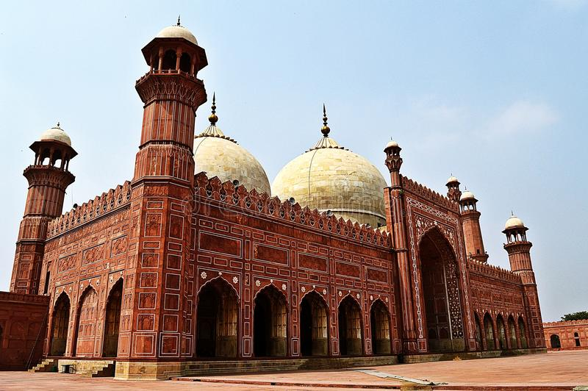

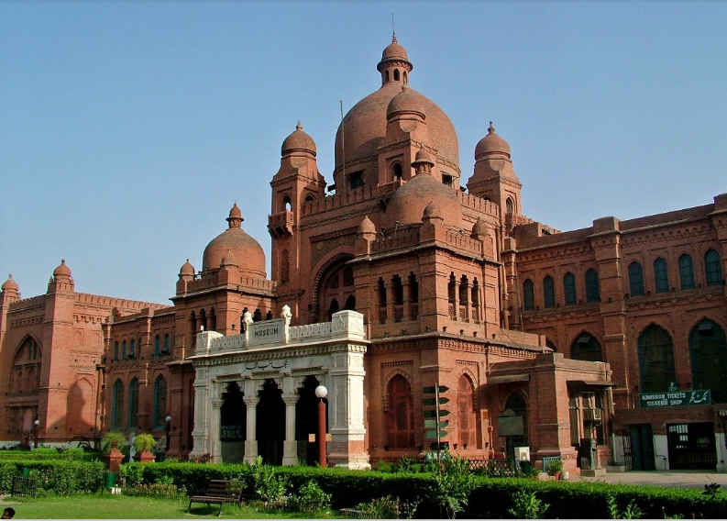

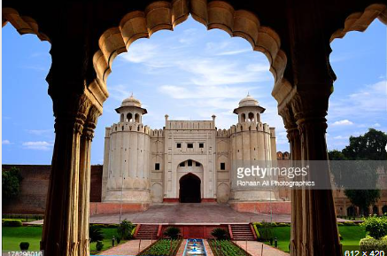

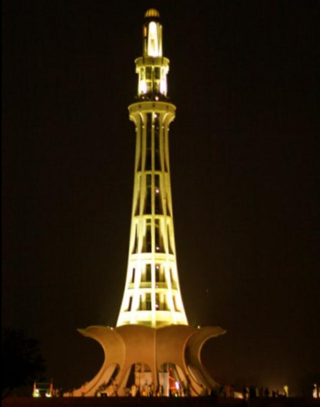

* **Reference**
* [**https://uol.edu.pk/discover-uol/lahorecity/**](https://uol.edu.pk/discover-uol/lahorecity/)
* [**https://lahore.punjab.gov.pk/geographic_conditions#:~:text=Lying%20between%2031%C2%B015,km%C2%B2%20and%20is%20still%20growing**](https://lahore.punjab.gov.pk/geographic_conditions#:~:text=Lying%20between%2031%C2%B015,km%C2%B2%20and%20is%20still%20growing)**.**
* [**https://pakspectrum.com/2022/10/23/how-to-promote-tourism-in-pakistan/#:~:text=By%20Increasing%20Resources%20We%20Can,promoting%20more%20than%2020%20sectors**](https://pakspectrum.com/2022/10/23/how-to-promote-tourism-in-pakistan/#:~:text=By%20Increasing%20Resources%20We%20Can,promoting%20more%20than%2020%20sectors)**.**